25 February 2019  CPD LECTURE: 4 CPD Points  Charity: 100% of the proceeds will go to The Capuchin Day Centre for Homeless People in Bow Street, Dublin  Time & Location: Thursday, 21 March 2019:  3.45pm to 7.00pm  The Capuchin Day Centre,  29 Bow Street, Dublin | 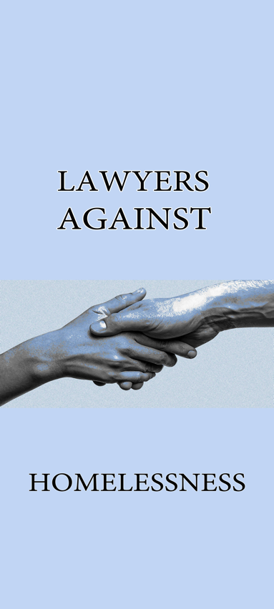
Dear Colleague,

Lawyers Against Homelessness was formed to assist Brother Kevin of the Capuchin Day Centre in his efforts to help the homeless.

Since November 2017, we have had four CPD conferences (3 per year), all of which were hosted by Brother Kevin in The Capuchin Day Centre.

100% of the proceeds of the conferences go to the Capuchin Day Centre – so far in excess of €85,000 has been raised.

Law firms involved include BLM, Gore & Grimes, Byrne Wallace, A&L Goodbody, McCann FitzGerald, Ennis, Kent Carty, Downes, Ivor Fitzpatrick, Hayes McGrath to name but a few. The Attorney General, Members of the Judiciary, the Bar Council, the Law Library and many members of the Bar are also involved.

The CPD conference fee is €100: however we have found that many of our colleagues have donated much in excess of this figure.

Brother Kevin has now introduced a new young family area in the Capuchin Day Centre, which caters especially for families. This is extremely important as recent statistics indicate that more than one in three people in emergency accommodation is a child.

This Seminar Is Open To All Members Of The Legal Profession. Please note that there is high interest in this seminar and in order to secure a place, the enclosed booking form must be completed and returned as soon as possible.

The object of the seminar is to bring practitioners up to speed on legal updates and subjects to be discussed will include the following:-
- Taxation
- Commercial law
- PI litigation updates
- Road Traffic legislation
- Licensing

SPECIAL GUEST
- Ms Justice Mary Irvine, Court of Appeal.

SOLICITORS’ FIRMS
- A&L Goodbody
- BLM
- Clark Hill
- Eames,
- O’Higgins
- Comptons
BARRISTERS
- Hugh O’Neill, S.C.
- Edward Walsh, S.C.
- Martin Dully, BL
- Shane English, B.L.
- Constance Cassidy, S.C.

We will also be asking some of the younger members of the profession to address the conferences.

FIRM SPONSORSHIP

We ask you, if you can afford it, for sponsorship of €500.00 per firm in order to assist The Capuchin Day Centre continue with their essential work. The benefits of sponsorship include:

- Five places at the seminar for members of the firm
- Name / logo on the seminar materials
- Firm pop-up banner at the seminar (if desired)
- Firm sponsors listed in the Parchment / Law Society magazine with photographs.

Please now complete the enclosed Booking Form and make cheque payable to The Capuchin Day Centre on or before Thursday, 7 March 2019 and send to Kate Reeves, c/o 5 Inns Court, Winetavern Street, Dublin 8.

Each Barrister/Solicitor, when registering for the seminar, will make a cheque payable directly to The Capuchin Day Centre in the sum of €100 per person for those with over 5 years PQE. For those with less than 5 years PQE, the amount is €50 per person.

It is advisable to book however payment can be made on the day in cash or cheque at registration.

Future Collaboration

In addition to sponsorship, please now confirm whether you would be interested in being involved in our upcoming seminars in June and/or November 2019.

Please now complete the enclosed Booking Form and make cheque payable to The Capuchin Day Centre on or before Thursday, 7 March 2019 and send to Kate Reeves, c/o 5 Inns Court, Winetavern Street, Dublin 8.

Kindest regards.

Yours faithfully,

Lawyers Against Homelessness

CONFERENCE INFORMATION

Date: 21 March 2019
Time: 3.30pm – 7.00pm
Location: The Capuchin Day Centre, 29 Bow Street, Dublin 7.
Fees: €100.00 per person (+5 years PQE)
€50.00 per person (-5 years PQE)
Registration: 3.45
Opening Address: 4.00
Conclusion & Closing: Presentations followed by questions and answers
CPD: 4 Hours PRACTICE MANAGEMENT

Please complete the registration form below and send this with your payment to:-
Lawyers Against Homelessness, Kate Reeves, c/o 5 Inns Court, Winetavern Street, Dublin 8.

Surname: __________________________________________________
First Name: __________________________________________________
Address: __________________________________________________
__________________________________________________
Telephone: _________________________________________
E-Mail Address __________________________________________________

Payment by Cheque: Payable to “The Capuchin Day Centre”

CONFIRMATIONS
Booking confirmations will be issued to all delegates by e-mail prior to the seminar. Please present your booking confirmation at the seminar registration desk.

DISCLAIMER
It may be necessary, for reasons beyond the control of the conference organisers, to alter the content and timing of the program or the identity of the speakers.

