4 June 2019  CPD LECTURE: 4 CPD Points  Charity: 100% of the proceeds will go to The Capuchin Day Centre for Homeless People in Bow Street, Dublin  Time & Location: Thursday, 27 June 2019:  3.30pm to 7.30pm  The Capuchin Day Centre,  29 Bow Street, Dublin | 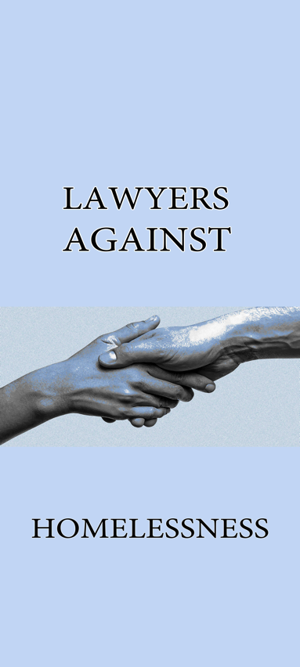
Dear Colleague,

The Chief Justice is launching our sixth CPD conference at the Capuchin Day Centre for Homeless People, Bow Street on Thursday, 27 June at 3:30pm.

To date, we have raised over €110,000 over the last year, every single penny of which has been given to Brother Kevin towards his lifelong fight against homelessness.

100% of the proceeds of the conferences go direct to the Capuchin Day Centre.

This is your great chance to get 4 CPD points before the long vacation, and do what you can to help the homeless.

Law firms which have been involved include BLM, Gore & Grimes, Byrne Wallace, A&L Goodbody, McCann FitzGerald, Ennis, Kent Carty, Downes, Ivor Fitzpatrick, Hayes McGrath and many others. The Attorney General, Members of the Judiciary, the Bar Council, the Law Library and many members of the Bar are also involved.

The CPD conference fee is €100 or €50 for practitioners in years one to five: however we have found that many of our colleagues have donated much in excess of this figure.

Brother Kevin has now introduced a new young family area in the Capuchin Day Centre, which caters especially for families. This is extremely important as recent statistics indicate that more than one in three people in emergency accommodation is a child.

This Seminar Is Open To All Members Of The Legal Profession. Please note that there is high interest in this seminar and in order to secure a place, the enclosed booking form must be completed and returned as soon as possible.

The object of the seminar is to bring practitioners up to speed on legal updates and subjects to be discussed will include the following:-
- Planning Law;
- Personal Injury Litigation
- Licensing;
- Defamation Law

SPECIAL GUEST
- The Chief Justice.
- Mr Justice Bernard Barton.
- Mr David Hegarty, Office of the Director of Corporate Enforcement.

SOLICITORS’ FIRMS
- McCann FitzGerald
- Arthur Cox
- Compton
- Mason Hayes & Curran
- BLM

BARRISTERS
- Richard Kean, S.C.
- Peter Bland, S.C.
- Conor Bowman, SC
- Brenda Power, B.L.
- Patrick Silke, B.L.

FIRM SPONSORSHIP

We ask you, if you can afford it, for sponsorship of €500.00 per firm in order to assist The Capuchin Day Centre continue with their essential work. The benefits of sponsorship include:

- Five places at the seminar for members of the firm
- Name / logo on the seminar materials
- Firm pop-up banner at the seminar (if desired)
- Firm sponsors listed in the Parchment / Law Society magazine with photographs.

Please now complete the enclosed Booking Form and make cheque payable to The Capuchin Day Centre on or before Thursday, 20 June 2019 and send to Kate Reeves, c/o 5 Inns Court, Winetavern Street, Dublin 8.

Each Barrister/Solicitor, when registering for the seminar, will make a cheque payable directly to The Capuchin Day Centre in the sum of €100 per person for those with over 5 years PQE. For those with less than 5 years PQE, the amount is €50 per person.

It is advisable to book however payment can be made on the day in cash or cheque at registration.

Future Collaboration

In addition to sponsorship, please now confirm whether you would be interested in being involved in our upcoming seminars in November 2019 or March 2020.

Please now complete the enclosed Booking Form and make cheque payable to The Capuchin Day Centre on or before Thursday, 20 June 2019 and send to Kate Reeves, c/o 5 Inns Court, Winetavern Street, Dublin 8.

Kindest regards.

Yours faithfully,

Lawyers Against Homelessness

CONFERENCE INFORMATION

Date: 27 June 2019
Time: 3.30pm – 7.30pm
Location: The Capuchin Day Centre, 29 Bow Street, Dublin 7.
Fees: €100.00 per person (+5 years PQE)
€50.00 per person (-5 years PQE)
Registration: 3.30pm
Opening Address: 4.00pm
Conclusion & Closing: Presentations followed by questions and answers
CPD: 4 Hours PRACTICE MANAGEMENT

Please complete the registration form below and send this with your payment to:-
Lawyers Against Homelessness, Kate Reeves, c/o 5 Inns Court, Winetavern Street, Dublin 8.

Surname: __________________________________________________
First Name: __________________________________________________
Address: __________________________________________________
__________________________________________________
Telephone: _________________________________________
E-Mail Address __________________________________________________

Payment by Cheque: Payable to “The Capuchin Day Centre”

DISCLAIMER
It may be necessary, for reasons beyond the control of the conference organisers, to alter the content and timing of the program or the identity of the speakers.

