SUMMER CONFERENCE    CPD LECTURE: 4 CPD Points  PLEASE HELP THE HOMELESS  Charity: 100% of the proceeds will go to The Capuchin Day Centre for Homeless People in Bow Street, Dublin  Time & Location: Thursday, 11 July 2024:  3.30pm to 7.30pm  The Capuchin Day Centre,  29 Bow Street, Dublin | 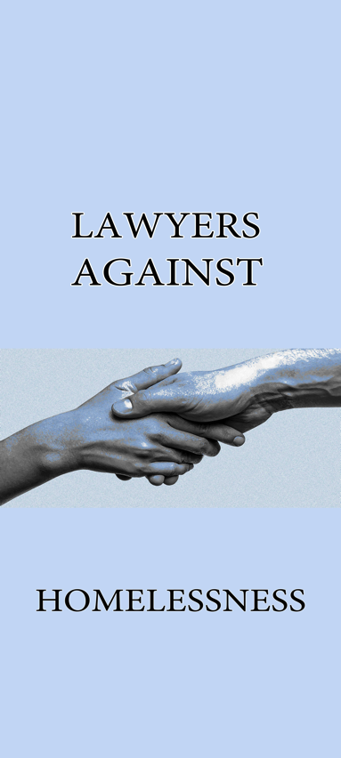
Dear Colleague,

Our summer CPD for the Capuchins is in the Capuchin Day Centre on Thursday, 11 July 2024: registration commences at 3:30pm and contributions from speakers listed below commence at 4:00pm.

We would be absolutely delighted if you could personally attend, together with any partners, or associates, or solicitors, or trainees in your office: the attendance of each and every person means a huge amount in terms of support and of course contributions to the charity.

This is now the 13th lecture and to date, we have made in excess of €385,000, every cent of which has gone direct to the Capuchin Day Centre.

As you are aware, and as indicated by the Incorporated Law Society, there has been a concomitant increase in the amount of CPD points which a solicitor must obtain on a yearly basis: it is essential that 5 in-person CPD points per year are obtained: we understand that the rest can be done on-line: because of this, we suggest that you obtain 4 of these by attending our CPD seminar at the Capuchin Day Centre.

TOPICS: Personal Injury, Commercial Law and Non-Jury

THE SPEAKERS INCLUDE THE FOLLOWING:

- Mr Justice Seamus Noonan, Judge of the Court of Appeal
- Ms Justice Niamh Hyland of The High Court
- Mr Joe O’Malley, Partner, Hayes Solicitors
- Megan Gilroy, Senior Associate, Arthur Cox
- Padraig McCartan SC
- Feichín McDonagh SC
- Shane Murphy SC
- Nouchka Lotefa BL
- Ciara Hughes, Ferry Solicitors

METHOD OF PAYMENT:

As you are reading this, we would ask you to reach out for your chequebook and write a cheque for between €500 to €1,000 made payable to Lawyers Against Homelessness or The Capuchin Day Centre.

Alternatively, you can immediately transfer a generous sum for the conference to Lawyers Against Homelessness:

Acc Name: LAWYERS AGAINST HOMELESSNESS
Acc No.: 54820258
IBAN: IE49 bofi 9000 9254 8202 58
Finally, you can pay cash on the day or alternatively you can present a credit card: we ask you to be as generous as possible.

100% of the proceeds of the conferences go direct to the Capuchin Day Centre.

Law firms which have been involved include BLM, Gore & Grimes, Byrne Wallace, A&L Goodbody, McCann FitzGerald, Ennis, Kent Carty, Downes, Ivor Fitzpatrick, Hayes McGrath and many others. The Attorney General, Members of the Judiciary, the Bar Council, the Law Library and many members of the Bar are also involved.

Your firm has been exceptionally supportive and has shown this by making extremely generous financial contributions.

As the requirements for CPD points have now increased, this is a very good and easy and worthwhile event to attend, which will earn you 4 points.

We are reaching out to you now to (a) attend yourself; (b) transfer a generous sum into the Lawyers Against Homelessness Bank Account and (c) try to bring along as many of your colleagues in your firm and trainees as you possibly can.

As you are aware, these events are held three times per year every March, July and November.

The CPD conference fee is €120 (or €60 for practitioners in years one to five): however we have found that many of our colleagues have donated much in excess of this figure.

Brother Kevin has now left the Capuchin Day Centre to retire after his many years supporting the homeless in Dublin.

His team remain utterly committed to helping the increasing issue of homelessness in Dublin: recent statistics indicate that more than one in three people in emergency accommodation is a child.

We have also been told of the hugely increasing burden because of the plight of Ukrainians fleeing their homeland.

This Seminar Is Open To All Members Of The Legal Profession. Please note that there is high interest in this seminar and in order to secure a place, the enclosed booking form must be completed and returned as soon as possible.

The object of the seminar is to bring practitioners up to speed on practice and procedure and subjects to be discussed will be:-

- Personal Injury
- Commercial Law
- Non-Jury

FIRM SPONSORSHIP

We ask you, if you can afford it, for sponsorship of €500.00 per firm in order to assist The Capuchin Day Centre continue with their essential work. The benefits of sponsorship include:

- Five places at the seminar for members of the firm
- Name / logo on the seminar materials
- Firm pop-up banner at the seminar (if desired)
- Firm sponsors listed in the Parchment / Law Society magazine with photographs.

Please now complete the enclosed Booking Form and make cheque payable to The Capuchin Day Centre on or before Thursday, 4 July 2024 and send to Kate Reeves, c/o 5 Inns Court, Winetavern Street, Dublin 8.

Each Barrister/Solicitor, when registering for the seminar, will make a cheque payable directly to The Capuchin Day Centre in the sum of €120 per person for those with over 5 years PQE. For those with less than 5 years PQE, the amount is €60 per person.

It is advisable to book however payment can be made on the day in cash or cheque at registration.

Future Collaboration

In addition to sponsorship, please now confirm whether you would be interested in being involved in our upcoming seminars in November 2024 or March 2025.

Let us know by emailing the within email address lah.conference@gmail.com to let us know if you would be prepared to speak on a topic in the future.

Please now (1) complete the enclosed Booking Form and (2) make cheque payable to The Capuchin Day Centre on or before Thursday, 4 July 2024 and send to Kate Reeves, c/o 5 Inns Court, Winetavern Street, Dublin 8 OR transfer to the above mentioned account with reference to your firm.

Kindest regards.

Yours faithfully,

Lawyers Against Homelessness

CONFERENCE INFORMATION

Date: 11 July 2024
Time: 3.30pm to 7.30pm
Location: The Capuchin Day Centre, 29 Bow Street, Dublin 7.
Fees: €120.00 per person (+5 years PQE)
€60.00 per person (-5 years PQE)
Registration: 3.30pm
Opening Address: 4.00pm
Conclusion & Closing: Presentations followed by questions and answers
CPD: 4 Hours PRACTICE MANAGEMENT

Please complete the registration form below and send this with your payment to:-
Lawyers Against Homelessness, Kate Reeves, c/o 5 Inns Court, Winetavern Street, Dublin 8.

Surname: __________________________________________________
First Name: __________________________________________________
Address: __________________________________________________
__________________________________________________
Telephone: _________________________________________
E-Mail Address __________________________________________________

Payment by Cheque: Payable to “The Capuchin Day Centre”
Alternatively, you can immediately transfer a generous sum for the conference to Lawyers Against Homelessness:

Acc Name: LAWYERS AGAINST HOMELESSNESS
Acc No.: 54820258
IBAN: IE49 bofi 9000 9254 8202 58

DISCLAIMER
It may be necessary, for reasons beyond the control of the conference organisers, to alter the content and timing of the program or the identity of the speakers.

